Differential Equations – Euler’s Method.

Euler’s Method is a way for numerically approximating the values of $y(t)$ when you know the value of the input $x(t)$ and have a differential equation of this form where a is a constant coefficient.
$$\frac{dy}{dt}+ay\left(t\right)=x(t)$$
Equation 1
$\frac{dy}{dt}$ can be approximated.
$$\frac{dy}{dt}= \frac{y\left(t+∆\right)-y(t)}{∆} as \lim_{→0}{∆}$$
Equation 2
Numerical approximation can never get $∆$ to be zero, but it can still make it very small. By making $∆$ to have a finite width, we invoke the rectangular approximation shown in the figures.
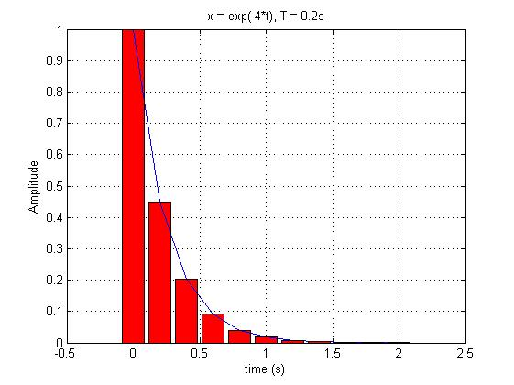
Figure 1

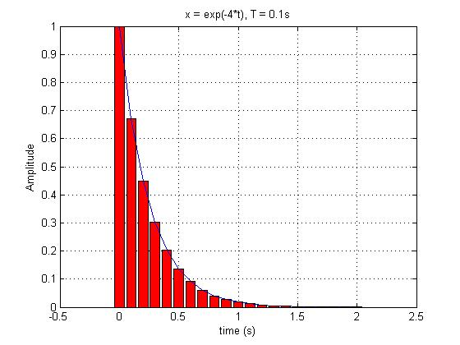
Figure 2

In both figures the blue line represents the curve, and the red bars represents the rectangular approximation for different values of $∆$. In Figure 1 $∆$ has a value of 0.2 seconds, and in Figure 2 $∆$ has a value of 0.1 seconds. Notice, as $∆$ gets smaller the better the rectangular approximation is to the actual curve.
When applying the numerical approximation using the rectangular approximation, $∆$ must be small enough to get an accurate approximation. You will notice that the steeper the slope, the smaller $∆$ must be to get a decent approximation of the actual curve. With working with numerical approximation $∆$ is the time step in the array that represents time. For example in MATLAB you would create a time array similar to the one below.
$t=Time_Beginning: ∆:Time_End$
By substituting Equation 2 into Equation 1 we create the equation.
$$\frac{y\left(t+∆\right)-y(t)}{∆} +ay\left(t\right)=x(t)$$
Equation 3
By rearranging the terms in Equation 3 we create the equation.
$$y\left(t+ ∆\right)=\left(x\left(t\right)-ay\left(t\right)\right)∆+y(t)$$
Equation 4
According to Equation 4, all values of $y(t)$ can be found as long as all values of $x(t)$ are known and the initial value of $y(t)$ is known.
This method can be applied to Impulse Responses of 2nd order LCCDEs. The 2nd order differential equation is split into two coupled first-order equations of the general form shown below. $h\left(t\right)$ represents the impulse response and $δ(t)$ represent the impulse into the system that is being described.
$$\frac{dh}{dt}+h\left(t\right)= δ(t)$$
Equation 5
To solve for $h\left(t\right)$, Equation 5 can be changed into the form shown in Equation 4.
$$h\left(t+ ∆\right)=\left(δ\left(t\right)-h\left(t\right)\right)∆+h(t)$$
Equation 6
The impulse function $δ\left(t\right)$ creates an issue since it has three strange properties:
- $δ\left(t-T\right)$ is zero everywhere except at its own location (t = T).
- It’s value is infinite at that location
- The total area under the impulse function is 1.
The impulse function can be represented graphically as $\lim_{→0}{ε}$.
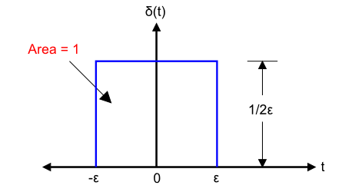
Figure 3
As the limit of $ε$ goes to zero the width of the impulse function become infinitesimally small, and the height becomes infinitely large. It is impossible to represent this numerically. However, we can use an approximation with the limit of $ε$ not being zero but rather a small finite number. This small finite number has to be the time step $∆$ since this represents the time step in the time vector. Using this approximation, Figure 3 can be changed.
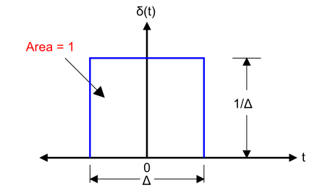
Figure 4
As $∆$ gets smaller, the closer it becomes to a true approximation of an impulse function with a height of 1/$∆$ and a width of $∆$. Using this approximation, Equation 6 becomes the form.

$$h\left(t+ ∆\right)=\left(\frac{1}{∆}-h\left(t\right)\right)∆+h(t)$$
Equation 7
The $\frac{1}{∆}$ is only part of Equation 7 at t= 0 since at this time the impulse function assumes a value other than 0.
The next issue to resolve is the initial condition of $h(t)$. Fortunately $h(t)$ must be causal; thus all values of $h(t)$ at t <0 must be zero. So at $h(-∆)$ the value is 0. Plugging this information into Equation 7 gives the value of $h(t)$ at t = 0.
$$h\left(0\right)=\left(0-h\left(-∆\right)\right)∆+h(-∆)$$
Equation 8
Simplifying Equation 8 yields.
$$h\left(0\right)=\left(0-h\left(-∆\right)\right)∆+h(-∆)$$
=>
$$h\left(0\right)=0$$
We now have the value of $h(t)$ at t = 0. We can now solve for $h(t)$ at t = $∆$.
$$h\left(∆\right)=\left(\frac{1}{∆}-h\left(0\right)\right)∆+h(0)$$
=>
$$h\left(∆\right)=\left(\frac{1}{∆}+0\right)∆+0$$
=>
$h\left(∆\right)=1$.
This process is repeated until all values of $h\left(t\right)$ are found.

