Convolution

The purpose of this document is not to substitute the book or class lecture, rather to be an additional reference that builds off of the book and class material. This document aims to aid people in understanding the intuition behind the nasty convolution formula, $y\left(t\right)= \int_{-∞}^{∞}{x\left(τ\right)h\left(t-τ\right)dτ}.$
The formula states that a specific value of y(t) is equal to the integral of the multiplication of two signals, systems, vectors, etc, with one signal being time reversed, over all time for a specific t. This will make more sense later. In electrical engineering the convolution formula can be modified or adapted to the way electrical engineers use convolution. Convolution is used to predict the behavior that some input signal will have on a system, and this predicted behavior is represented by y(t). In the real world, y(t) can never depend on something that hasn’t happened. This fact limits the upper bound of integration to t, $y\left(t\right)= \int_{-∞}^{t}{x\left(τ\right)h\left(t-τ\right)dτ}$ . Now, y(t) can only depend on past and current inputs. The formula can be modified further.
Time is arbitrary, in that people have the ability to reference the beginning of events to a specific time. For example, each new day starts at 0 A.M. and goes till 12 P.M. Would any meaning of a day changed if the day started at -1 A.M. and ended at 11 P.M.? Another example is playing a song on an mp3 player. Whether you play a song today or tomorrow it will be the same. When you first push play you will often see a bar that measures the elapsed time with time starting at zero. When you push play it is not really 0 o’clock, rather it is a reference to the beginning of a certain event. In a similar way the event of a signal entering a system can be referenced to occur at t = 0. This, in addition to the fact that signals are causal, allows the convolution integral to be modified even further, $y\left(t\right)= \int_{0}^{t}{x\left(τ\right)h\left(t-τ\right)dτ}$. This is possible since the systems and signals that you will work with are time-invariant.
h(t) is the impulse response that is measured by sending an impulse, $δ(t)$, into the system. An example of an impulse response can be an echo. Imagine yourself out in the mountains and you make a sharp, loud, short yell and then listen. You will hear an echo that is loud at first and then slowly attenuates. The mountains (system) took your yawp and changed its phase, duration, and amplitude in the form of an echo. If you were to measure the echo, you would have the impulse response of the mountains. The concept to understand is that the effects of the yawp can last longer than the actual yawp.
In electrical engineering, circuits can be mathematically modeled by an impulse response by stimulating the circuit with an impulse. For the rest of the document the circuit below will be the referenced system that will be modeled by an impulse response. It is taken out of the book (Ulbay and Yagle, Engineering and Signals and Systems pg 46).
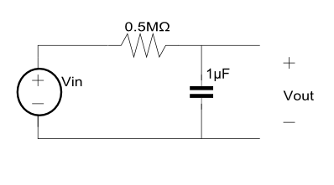
The impulse response of the circuit is, $h\left(t\right)=2e^{-2t}u(t)$. The following images will graphically demonstrate this.
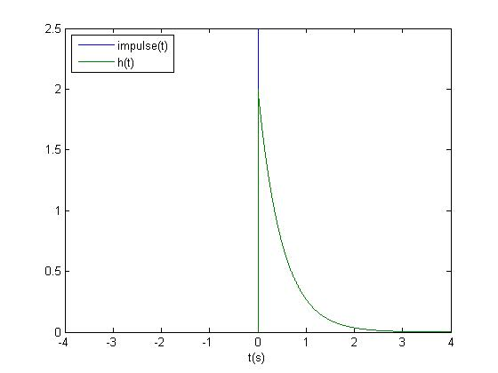
The impulse response, h(t), of the above circuit is represented graphically in the image above by the green curve. The blue line represent the impulse that will be sent into the system. When convolving two signals together, one of the signals is time reversed, and the commutative property allows either signals to be the signal that is time reversed. In this example, the impulse will be time reversed $y\left(t\right)= \int_{-∞}^{∞}{δ\left(t-τ\right)h\left(τ\right)dτ}.$ This is depicted in the next image.
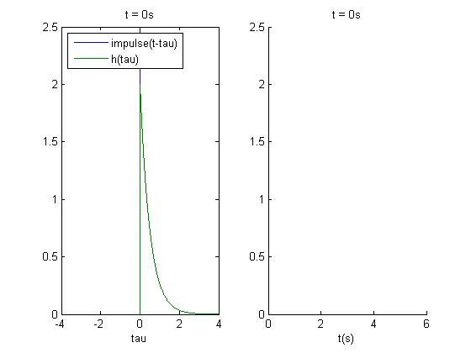
The graph on the left represent the signal entering into the system, and the graph on the right will represent the output of the signal. Notice that the x-axis in the graph on the left is in terms of tau (a dummy variable), and the x-axis in the image on the right is in t (s). On the top of each graph is the current time with t = 0. This corresponds to the time elapsed from when the signal first entered the circuit and to y(t).

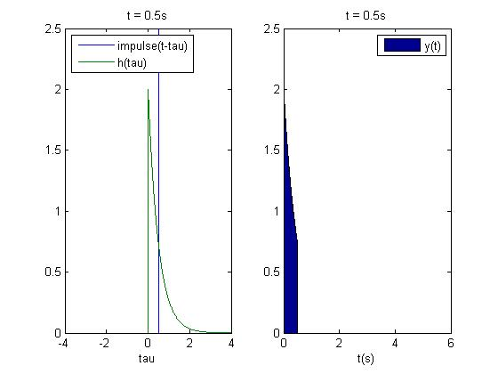
At t = 0s, the impulse entered the circuit and excited an output of about 2V. As time progressed, the impulse moved along the tau axes and the output is shown in the graph on the right. This isn’t saying that the impulse is “still in the system” rather that the effects of the impulse are still noticeable just like an echo lasts longer than the actual yawp. In terms of a circuit with a capacitor, at t = 0s the capacitor was charged to about 2V, and has been slowly discharging for 0.5s to 0.75V.
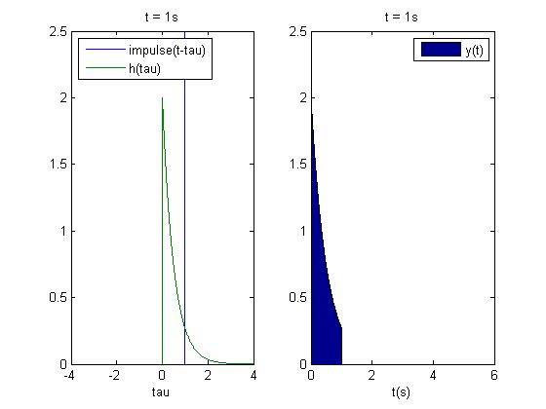
The impulse is now at t = 1s, and capacitor continues to decay. Just like an echo continues to attenuate. Remember that there is nothing being applied to the circuit at t =1s. What is being observed at the output is the after effect.

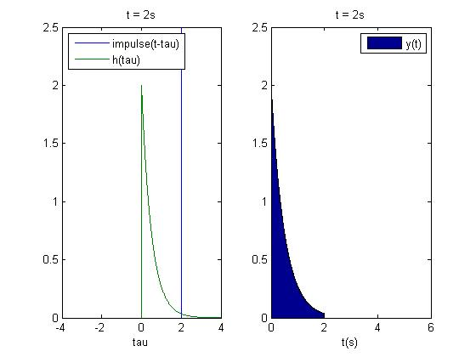
At t = 2s the impulse graphically continues to move, and the voltage continues to attenuate.

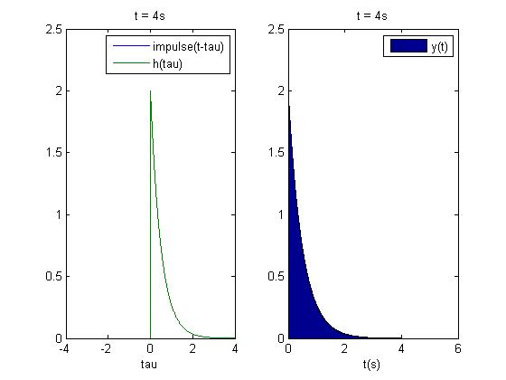
At t = 4s the output voltage has decayed to almost zero. Thus the effects of an impulse on this specific circuit lasted for about 4s. In other words if you attached an impulse at Vin in the circuit above, a voltmeter would read an output voltage with the waveform in the graph on the right. Now imagine that the circuit is stimulated by two impulse functions, one at t =0s and another at t =0.5s. Before the capacitor can discharge completely, it is excited by another impulse. The output of this is shown in the image below.
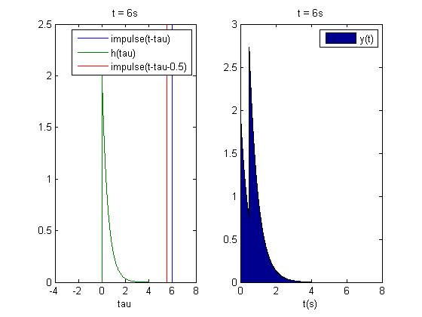
At t = 6s the two impulses and their effects have moved through the system. Notice at t = 0⁺s the first impulse just entered the system and caused a spike of 2V. Now notice that at t = 0.5s, when the second impulse entered the system, the output experienced a huge spike from about 0.75 volts to about 2.75 volts. Without the second impulse, the voltage would be 0.75 volts. Essentially what this is showing is that y(t) = h(t) + h(t-0.5). This demonstrates the distributive property. Thus y(t) was dependent on present and past inputs. This also leads into what would happen if the circuit was excited by a continuous circuit that lasted longer than an infinitesimally small period of time.

We have now analyzed the effect an impulse has on a circuit. Now, we will analyze the effect a rect(t) function has on the same circuit. The rect(t) function that will be used can be modeled as, x(t) = u(t) – u(t-1); The image below shows both x(t), and h(t).
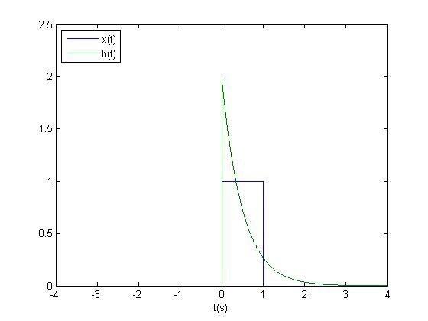
The rect(t) function is shown in blue and the impulse response is shown in green. The graph above shows the two functions as functions of time. t = 0 corresponds to the beginning of the rect(t) signal, or the part of the signal that will first enter the circuit. t = 1 corresponds to the end of the rect(t) signal, or the part of the signal that will enter the circuit last. To show the proper time order in which x(t) enters a system described by h(t), the impulse response or the rect function must be flipped about the y-axis. The image below demonstrates this. As time goes on, the first part of the rect signal will begin to overlap with the first part of the impulse response function simulating the signal first entering into the system. As h(t) shifts, the first part of h(t) will overlap with later parts of x(t) simulating the entering of a later portion of the signal into the system. This is the reason behind the time reverse in h(t-tau).
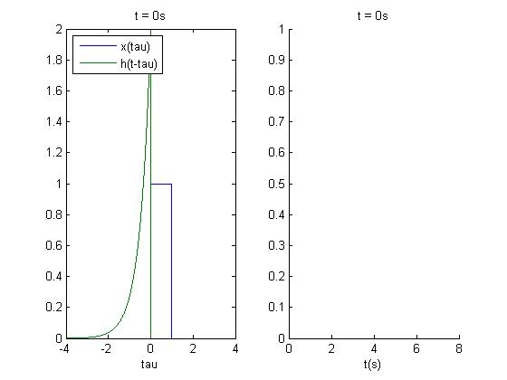
This image is similar to the previous ones seen. The graph on the left shows the signal entering the system with time, and the graph on the right shows the convolved signal, or the output. The graph on the left has an x-axis in terms of tau, and the graph on the right has an x-axis in terms of t. On the top of each graph is the corresponding time. Remember that convolution is commutative, so it doesn’t matter which signal is time reversed about the y-axis. The important thing that it models is that at t = 0⁻s the signal has not entered the system by not having h(t) overlapping x(t). As time progresses, the signal will begin to enter the system. This is shown in the image below.
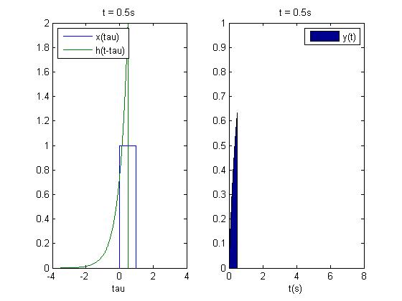
At t = 0.5s, the signal has entered the system. The overlapping area of the two signals represents the present signal that is exciting the circuit and the after effects of all the previous signals. By summing the present excitation and lingering effects cause by previous signals, the value of y(t= 0.5s) can be attained. That is the purpose of the integral in the convolution formula, $y\left(t=0.5\right)= \int_{0}^{0.5}{x\left(τ\right)h\left(0.5-τ\right)dτ}$.
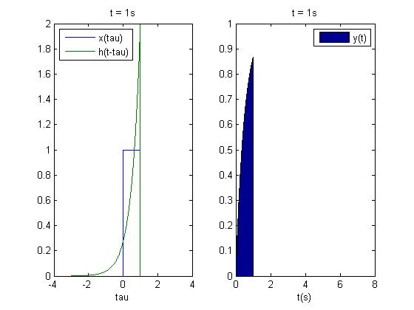
At t = 1s the last portion of the signal x(t) enters the circuit. Now, with nothing to stimulate the circuit, the output should begin to decay.

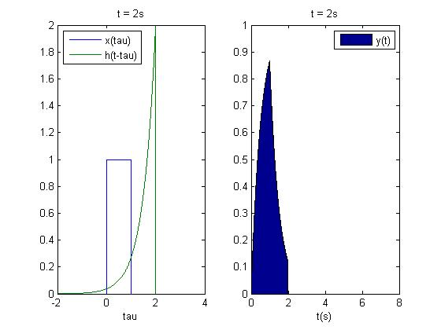
At t = 2s the decay is conspicuous.
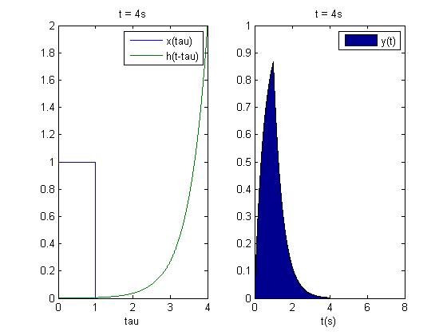
At t = 4s the circuit has not been stimulated for 3 seconds and thus the capacitor contains almost no energy.

Summary
The bounds of integration are changed from (-inf to inf) to (0 to t) in order to model a causal circuit and system. An input into a system can cause an output that lasts longer than the input just like an echo in the mountains. A signal is time reversed in the convolution integral to properly reflect the way a signal enters a system with t=0s being the first part, and t = inf being the last part. The current output depends upon the current input and the fading effects of all past inputs.
Hopefully this is helpful. If not, ask a TA.

